Rolling Marble Simulation Playbook
I. Challenge
Design and execute an embedded Hardware-in-the-Loop (HIL) physics engine that models the dynamic kinematics of a virtual sphere rolling along a circular path. The system must translate continuous spatial data from an inertial sensor into dynamic physical properties—such as inertia, momentum, friction, and mass—and map the resulting high-precision floating-point coordinates onto a discrete 16-LED addressable display ring with zero latency at a steady $50\text{ Hz}$ execution loop.
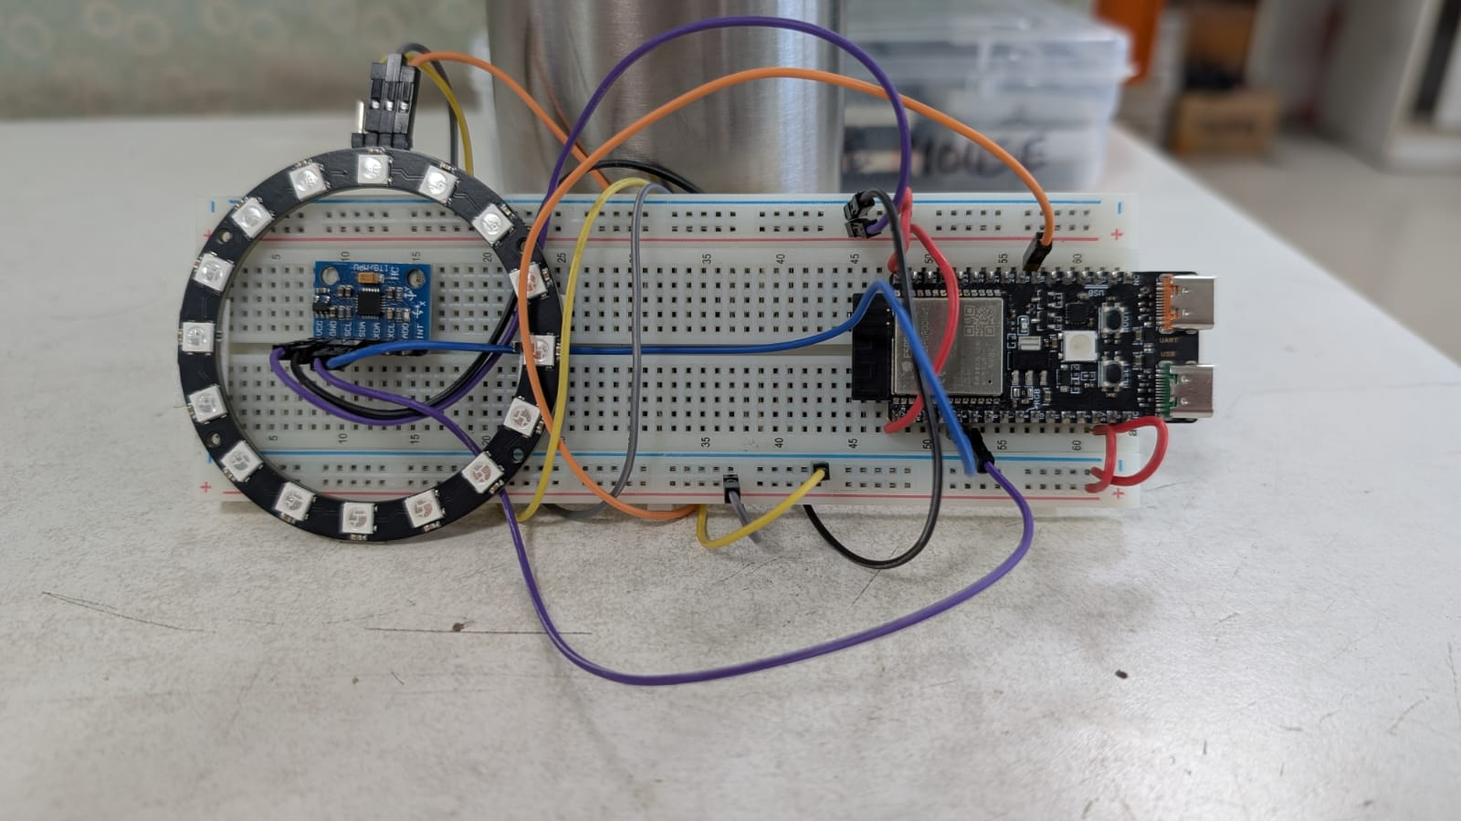
II. Guide
A. Concept
To implement a responsive, realistic physics simulation on a microcontroller, we apply these key trigonometric and classical mechanics concepts:
- 1. Downhill Incline Resolver: Micro-electromechanical system (MEMS) accelerometers measure raw gravitational vectors along spatial axes. To isolate the true direction that gravity pulls a physical object downwards, the system relies on the two-argument arctangent function:
$$θ_{\text{target}}=\text{atan2}\left(x_{\text{Angle}},y_{\text{Angle}}\right)×\frac{180}{π}$$
This evaluates the quadrant signs to map the absolute tilt target from $0^{∘}$ to ${360}^{∘}$.
  - Learn more: The Mathematics of the Atan2 Function
- Modular Angular Distance & Wrap-Around: Direct subtraction ($θ_{\text{target}}-θ_{\text{marble}}$) breaks down across the $0^{∘}/{360}^{∘}$ boundary, causing false rotational directions. The physics engine constrains angular error to $\left[-{180}^{∘},{180}^{∘}\right]$ to ensure the simulated marble always takes the shortest physical path around the circular track.
  - Learn More: Stack Overflow – Finding the Shortest Distance Between Two Angles
- 3. Semi-Implicit Euler Numerical Integration: Instead of complex continuous equations, the physics engine updates the particle across tiny discrete slices of time ($Δt=20\text{ ms}$). Restoring torque yields acceleration, which modifies the current velocity before being compressed by a damping factor ($μ$) representing surface friction:
$$v_{t}=\left(v_{t-1}+a\right)×μ$$
$$x_{t}=x_{t-1}+v_{t}$$
  - Learn more: Numerical Integration
- 4. Continuous-to-Discrete Remapping: The physics core operates entirely with high-precision floating-point variables to maintain momentum accuracy. To display this on hardware, the continuous angle must be scaled, rounded to the nearest integer index, and wrapped using a modulo operation to light the correct pixel:
$${\text{Index}}_{\text{LED}}=\left\lfloor \text{round}\left(\frac{θ_{\text{marble}}}{360/N_{\text{LEDs}}}\right)\right\rfloor \left(mod N_{\text{LEDs}}\right)$$
  - Learn more: Quantization Error Explained
Real-World Example: Advanced stability control systems in aerospace rocketry, smartphone screen orientation adjustments, and active anti-sway suspension structures in high-performance automotive platforms. They sample real-time tilt vectors to shift virtual or mechanical elements against gravity.
B. Components
- Microcontroller: WeAct Studio ESP32-C6 Dev Board.
- Motion Sensor: MPU6050 6-DoF Inertial Measurement Unit.
- Visualizer Array: $16$-element WS2812B NeoPixel RGB LED Ring.
- Interconnect Base: Solderless breadboard and jumper hookup wires.
C. Connections
The system uses an $I^{2}C$ protocol channel to extract the sensor readings and a high-speed one-wire pulse control channel to update the lighting ring:
Source Device | Pin Label | Target MCU Pin (ESP32-C6) | Operational Functional Description
MPU6050 IMU | VCC | 3.3V | Logic Power Supply
 | GND | Gnd | Common Ground Reference
 | SDA | GPIO 6 | Hardware $I^{2}C$ Serial Data Communication
 | SCL | GPIO 7 | Hardware $I^{2}C$ Serial Clock Line
NeoPixel Ring | 5V | V5 / VIN | High-Current Input (Direct USB $5\text{V}$ Rail)
 | GND | Gnd | Common Ground Reference
 | DI | GPIO 18 | High-Speed Digital Pixel Control Input
 | DO | Unconnected | Open Daisy-Chain Output Pass-through

D. Code
This program sets up the hardware lines, calibrates the gyroscope base offset, and runs the integration equations at a consistent $50\text{ Hz}$ step interval:
1. #include <Wire.h>
2. #include <MPU6050_tockn.h>
3. #include <Adafruit_NeoPixel.h>
4.
5. #define LED_PIN 18
6. #define NUM_LEDS 16
7. #define I2C_SDA 6
8. #define I2C_SCL 7
9.
10. MPU6050 mpu6050(Wire);
11. Adafruit_NeoPixel ring(NUM_LEDS, LED_PIN, NEO_GRB + NEO_KHZ800);
12.
13. // --- PHYSICS ENGINE VARIABLES ---
14. float marblePos = 0.0; // Current position of the marble in degrees (0.0 to 360.0)
15. float marbleVelocity = 0.0; // Current angular velocity
16. const float FRICTION = 0.92; // Damping factor (0.99 = ice/no friction, 0.80 = heavy mud)
17. const float GRAVITY_MULT = 0.02; // How responsive the marble is to gravity/weight
18.
19. void setup() {
20. Serial.begin(115200);
21. Wire.begin(I2C_SDA, I2C_SCL);
22.
23. ring.begin();
24. ring.setBrightness(40);
25. ring.show();
26.
27. Serial.println("Place flat for IMU calibration...");
28. mpu6050.begin();
29. mpu6050.calcGyroOffsets(true);
30. Serial.println("Physics Engine Ready!");
31. }
32.
33. void loop() {
34. mpu6050.update();
35. float xAngle = mpu6050.getAngleX();
36. float yAngle = mpu6050.getAngleY();
37.
38. // 1. Calculate overall tilt steepness (Magnitude)
39. float tiltMagnitude = sqrt((xAngle * xAngle) + (yAngle * yAngle));
40.
41. // 2. Only update physics if the board is actually tilted
42. if (tiltMagnitude > 2.0) {
43. // Find the downhill target angle where gravity pulls a marble (opposite of bubble level)
44. float targetAngle = atan2(xAngle, yAngle) * 180.0 / M_PI;
45. if (targetAngle < 0) targetAngle += 360.0;
46.
47. // 3. Calculate shortest angular distance to target (handles 0/360 wrap-around)
48. float angularError = targetAngle - marblePos;
49. if (angularError > 180.0) angularError -= 360.0;
50. if (angularError < -180.0) angularError += 360.0;
51.
52. // 4. Euler Integration: Accel -> Velocity -> Position
53. float acceleration = angularError * tiltMagnitude * GRAVITY_MULT;
54.
55. marbleVelocity += acceleration;
56. marbleVelocity *= FRICTION; // Apply simulated surface resistance
57. marblePos += marbleVelocity;
58.
59. // Keep marble position strictly within 0-360 degrees
60. if (marblePos >= 360.0) marblePos -= 360.0;
61. if (marblePos < 0.0) marblePos += 360.0;
62. } else {
63. // If the board is perfectly flat, slowly bleed off any remaining velocity
64. marbleVelocity *= 0.5;
65. marblePos += marbleVelocity;
66. }
67.
68. // 5. Map the float position angle to the nearest integer LED index
69. int currentLED = ((int)round(marblePos / (360.0 / NUM_LEDS))) % NUM_LEDS;
70.
71. // 6. Render the Marble
72. ring.clear();
73.
74. // Draw the main marble (Bright Blue)
75. ring.setPixelColor(currentLED, ring.Color(0, 150, 255));
76.
77. // Draw a dim "tail" or motion blur behind the marble based on velocity direction
78. int tailLED = (marbleVelocity > 0) ? (currentLED - 1 + NUM_LEDS) % NUM_LEDS : (currentLED + 1) % NUM_LEDS;
79. if (abs(marbleVelocity) > 2.0) {
80. ring.setPixelColor(tailLED, ring.Color(0, 40, 100));
81. }
82. ring.show();
83.
84. delay(20); // Steady 50Hz frame rate for smooth physics integration
85. }
86.

III. Play & Share
- Introduce Elastic Boundary Collisions: Instead of allowing the marble to spin continuously all the way around the ring, create a virtual brick barrier at LED index 0 and 8. Modify your integration code so that if the marble's position hits a barrier, the position stops instantly, and the velocity multiplies by -0.6 to bounce backwards!
- Simulate Multi-Body Physics: Expand your array parameters to introduce a second marble onto the track. Can you write a software check that senses when both indexes share the same discrete space and performs an elastic momentum swap so the particles bump away from each other?
- Design a Dynamic Maze Game: Use the code to build a game where a player tilts the board to guide the marble into a designated, blinking "target gate" LED within a specific time limit while avoiding dynamic, red "trap" LEDs that reset the score.

